## A Course Based Project Report On

**Ticket Booking System (Airways)**

## Submitted in partial fulfilment of requirement

**for the completion of** **DATABASE MANAGEMENT SYSTEMS**

## LABORATORY

**B.Tech Computer Science and Engineering**

## By

**1. S. Raja Sree(23071A05U6)**

## 2. S. Suraj(23071A05U7)

## 3. V. Shivanvitha(23071A05V0)



### VALLURIPALLI NAGESWARARAO VIGNANA JYOTHI INSTITUTE OF ENGINEERING AND

### TECHNOLOGY

**VignanaJyothi Nagar, Bachupally, Nizampet (s.o), Hyderabad 500090Phone no: 040-23042758/59/60**

## 2024-2025

**A Course Based Project Report On**

## Ticket Booking System (Airways) Submitted in partial fulfilment of requirement

**For the completion of the**

## Database Management Systems Laboratory course.

**B.Tech Computer Science and Engineering Under the Guidance of**

## Dr. Madhu Bala Myneni

**CSE Department**



## 

## VNR Vignana Jyothi Institute of Engineering and Technology

**Bachupally(v), Hyderabad, Telangana, India.**

**CERTIFICATE**

This is to certify that the project entitled **"Ticket booking System (Airways)"** submitted in partial fulfilment for the course of Database Management Systems Laboratory (22PC2AM201) being offered for the award of B.Tech (CSE) by VNR VJIET is a result of the bonafide work carried out by **S. Raja Sree(23071A05U6), S. Suraj(23071A05U7) and V. Shivanvitha(23071A05V0)** during the year 2024-2025. This has not been submitted for any other certificate or course. This work is carried out under supervision and has not been submitted to any other University/Institute for award of any degree/diploma.

### Signature of Faculty Signature of

**Head of the Department**

**ACKNOWLEDGEMENT**

An endeavor over a long period can be successful only with the advice and support of many well-wishers. We take this opportunity to express our gratitude and appreciation to all of them.

We wish to express our profound gratitude to our honorable **Principal, Dr. C. D. NAIDU and HOD, Dr. V. Baby, CSE department, VNR Vignana Jyothi Institute of Engineering and Technology** for their constant and dedicated support towards our career molding and development.

With a great pleasure we express our gratitude to the internal guide **Dr. Madhubala Myneni, Professor, CSE department** for her timely help, constant guidance, cooperation, support and encouragement throughout this project as it has urged us to explore many new things.

Finally, we wish to express our deep sense of gratitude and sincere thanks to our parents, friends and all our well-wishers who have technically and non-technically contributed for the successful completion of this course-based project.

**DECLARATION**

We do declare that the project entitled **“Ticket Booking System for airways”** submitted to the Department of Computer Science and Engineering (CSE), Vallurupalli Nageswara Rao Vignana Jyothi Institute of Engineering and Technology , Hyderabad, in partial fulfillment of the requirement for the completion of the Database Management Systems lab course of BACHELOR OF TECHNOLOGY in Computer Science and Engineering is the bonafide record of the project report presented under the supervision of Dr. M. Madhubala, Professor, CSE Dept, VNR VJIET .

### Signature of the Student Date:

1. S. Raja Sree (23071A05U6)

2. S. Suraj (23071A05U7)

3. V. Shivanvitha (23071A05V0)

**TABLE OF CONTENTS**

|  |  |  |
| --- | --- | --- |
| **S.no** | **Section Reference** | **Page no** |
| 1 | ABSTRACT | 8 |
| 2 | INTRODUCTION | 9 |
| 3 | DATABASE SCHEMA | 10 |
| 4 | NORMALISATION | 11 |
| 5 | IMPLEMENTATION and RESULTS | 12-15 |
| 6 | QUERIES (SOLUTIONS) | 16-19 |
| 7 | CONCLUSION | 20 |

**ABSTRACT**

A Ticket Booking System for Airways is a database-driven application designed to simplify and automate air travel booking processes. The system handles critical operations like flight details, customer details, journey details and ticket issuance. Using **Database Management System (DBMS)** principles, it ensures efficient data management, reliability, and scalability.

Built on a relational database, the system organizes and retrieves data for flights, passengers and bookings while ensuring integrity through normalization and constraints.

At its core, the system leverages a relational database model to store and manage data related to flights, passengers, bookings, and ticket records. Features such as real-time flight availability checks are implemented to enhance functionality and user experience. By integrating ER modeling, relational schema design, and structured query processing, the system ensures data integrity, consistency, and accuracy while providing users with seamless access to necessary information.

This project highlights the practical application of DBMS in addressing real-world challenges such as scalability, data consistency, demonstrating how database design can enhance operational efficiency and customer experience in the aviation sector.

**INTRODUCTION**

The aviation industry relies heavily on technology for operational efficiency and customer satisfaction. A robust Ticket Booking System for Airways is essential for managing the complexity of flight schedules, and passenger information. This project focuses on building a database-driven system that automates the ticket booking process, reduces human errors, and improves the overall user experience.

The core of the system lies in its database, which stores critical information such as flight details, passenger data, and ticket issuance logs. Utilizing ER modelling and a relational database schema, the system ensures logical data representation and efficient query handling.

By implementing these concepts, this project demonstrates the practical utility of DBMS in real-world applications. Moreover, it addresses challenges like concurrency control, data consistency, and query performance optimization. This system is an example of how well-designed databases can streamline operations and enhance service delivery in industries with extensive data handling requirements.

# DATABASE SCHEMA

Airport

Continent

DepartureDate

Destination

Continent

SourceAirportCode

CountryCode

CountryName

DepartureDate

flightCode

Destination

Passport No

Source

Nationality

Name

Ticket

PNR

Phone

Nationality

Address

Gender

Name

has

maintain

Passenger

Flights

Reservations

has

as

PassportNo

### Passenger:

**Attributes:** Name, Nationality, Phone, Address, PassportNo, Gender.

**Relationships:** One Passenger can have multiple Reservations.

**Reservations:**

**Attributes:** PNR, Ticket, PassportNo, Name, Nationality, Source, Destination, flightCode, departureDate.

**Relationships:** One Reservation belongs to One Passenger. One Reservation is associated with a Flight.

### Flights:

**Attributes:** SourceAirportCode, CountryCode, Country Name, Airport continent, Continent, Departure Date, Destination.

**Relationships: Loan:** One Flight can have multiple Reservations.

# Process of Normalization

### Normalization:

Normalization in the airways ticket booking system involves structuring data to minimize redundancy and dependency issues. This is achieved by reviewing relationships, keys, and dependencies in each entity and ensuring compliance with various normal forms. Given the system where the database uses jdbc to connect to java, and a csv file provides flight details, we can structure and normalize the passenger and reservation tables. Here's the process of normalization:

### First Normal Form (1NF):

All attributes in each relation should be single-valued.

In the ticket booking system:

For the Passenger table, ensure each attribute such as, Name, and Contact Information contains atomic

values.

For the Reservation table, attributes like PNR, Flight code and ticket Number must also hold

single values.

**Second Normal Form (2NF):**

No partial dependency should exist.

Every non-prime attribute should be fully functionally dependent on the entire primary key.

In the ticket booking system:

For Passenger table, if Passenger passport is the primary key, ensure attributes like Name and Contact

Info are fully dependent on passport number.

### Third Normal Form (3NF):

No transitive dependency should exist.

All attributes should be functionally dependent only on the primary key. In the ticket booking system:

For the Reservation table, if attributes like Flight Source and Flight Destination are included and depend on Flight Number, this creates a transitive dependency (Ticket number → Flight Number → Flight Source).

# IMPLEMENTATION and RESUTS

### CREATION OF TABLES:

**Passenger Table:**

CREATE TABLE Passenger (

Name VARCHAR(20) NOT NULL,

Nationality VARCHAR(20) NOT NULL,

Phone VARCHAR(15) NOT NULL,

Address VARCHAR(50) NOT NULL,

PassportNo VARCHAR(15) NOT NULL,

Gender VARCHAR(20) NOT NULL

);

### Reservation table:

CREATE TABLE Reservation (

PNR VARCHAR(15) NOT NULL,

Ticket VARCHAR(20) NOT NULL,

PassportNo VARCHAR(50) NOT NULL,

Name VARCHAR(20) NOT NULL,

Nationality VARCHAR(30) NOT NULL,

Source VARCHAR(50) NOT NULL,

Destination VARCHAR(50) NOT NULL,

FlightCode VARCHAR(10) NOT NULL,

DepartureDate VARCHAR(30) NOT NULL

);

### dbmsexl_csv table:

CREATE TABLE dbmsexl_csv(

SourceAirportCode TEXT NOT NULL,

CountryCode TEXT NOT NULL,

CountryName TEXT NOT NULL,

AirportContinent TEXT NOT NULL,

Continent TEXT NOT NULL,

DepartureDate TEXT NOT NULL,

Destination TEXT NOT NULL

);

### DATA INSERTIONS:

**PASSENGER TABLE:**

INSERT INTO passenger (name, nationality, phone, address, passportno, gender)

VALUES

('anvitha vothe', 'indian', '6758453475', 'fgt4ferfgr', '12345678932', 'Female'),

('varshini', 'indian', '24348554655', 'hyderabad', 'IN-23445534', 'Female'),

('Rajasree', 'indian', '8457480308', 'Telangana', 'IN37294302', 'Female'),

('John', 'British', '3834502942', 'Manchester', 'UK8570350', 'Male'),

('Lewis', 'American', '2948984394', 'Los Angeles', 'US5935041', 'Male'),

('Angela', 'American', '3848934290', 'San Francisco', 'US59358014', 'Female'),

('Kamala', 'indian', '9348247830', 'Chennai', 'IN75487534', 'Female'),

('Varun', 'British', '2395748290', 'Bradford', 'UK4272859', 'Male'),

('Travis', 'Canadian', '4897522489', 'Vancouver', 'CA34598349', 'Male'),

('Bella', 'Irish', '8472875842', 'Dublin', 'IR43287428', 'Female');

SELECT * FROM passenger;

|  |  |  |  |  |  |
| --- | --- | --- | --- | --- | --- |
| Name | Nationality | Phone | Address | Passport No | Gender |
| anvitha vothe | indian | 6758453475 | fgt4ferfgr | 12345678932 | Female |
| varshini | indian | 24348554655 | hyderabad | IN-23445534 | Female |
| Rajasree | indian | 8457480308 | Telangana | IN37294302 | Female |
| John | British | 3834502942 | Manchester | UK8570350 | Male |
| Lewis | American | 2948984394 | Los Angeles | US5935041 | Male |
| Angela | American | 3848934290 | San Francisco | US59358014 | Female |
| Kamala | Indian | 9348247830 | Chennai | IN75487534 | Female |
| Varun | British | 2395748290 | Bradford | UK4272859 | Male |
| Travis | Canadian | 4897522489 | Vancouver | CA34598349 | Male |
| Bella | Irish | 8472875842 | Dublin | IR43287428 | Female |

### RESERVATION TABLE:

INSERT INTO reservation (PNR, TICKET, passportno, name, nationality, src, des, fcode, ddate)

VALUES

('PNR-409813', 'TIC-64537', 'IN-23445534', 'varshini', 'indian', 'hyd', 'del', '15745', '30-Nov-2024'),

('PNR-376454', 'TIC-26192', 'IN-34566697', 'anvitha vothe', 'indian', 'AFC', 'CXF', '17866', '26-Nov-2024'),

('PNR-341287', 'TIC-52731', 'UK8570350', 'John', 'British', 'uk', 'aus', '60438', '19-Dec-2024'),

('PNR-531947', 'TIC-47080', 'US5935041', 'Angela', 'American', 'washington', 'canada', '32822', '25-Dec-2024'),

('PNR-894232', 'TIC-58607', 'UK4272859', 'Varun', 'British', 'london', 'australia', '86642', '25-Dec-2024'),

('PNR-879818', 'TIC-14087', 'CA34598139', 'Travis', 'Canadian', 'canada', 'sydney', '66594', '21-Dec-2024'),

('PNR-980608', 'TIC-40380', 'IR43287428', 'Bella', 'Irish', 'belgium', 'paris', '47333', '29-Dec-2024');

SELECT * FROM reservation;

|  |  |  |  |  |  |  |  |  |
| --- | --- | --- | --- | --- | --- | --- | --- | --- |
| PNR | TICKET | Passport No. | name | nationality | src | des | fcode | ddate |
| PNR-409813 | TIC-64537 | IN-23445534 | varshini | indian | hyd | del | 15745 | 30-Nov-2024 |
| PNR-376454 | TIC-26192 | IN-34566697 | anvitha vothe | indian | AFC | CXF | 17866 | 26-Nov-2024 |
| PNR-341287 | TIC-52731 | UK8570350 | John | British | uk | aus | 60438 | 19-Dec-2024 |
| PNR-531947 | TIC-47080 | US5935041 | Angela | American | washington | canada | 32822 | 25-Dec-2024 |
| PNR-894232 | TIC-58607 | UK4272859 | Varun | British | london | australia | 86642 | 25-Dec-2024 |
| PNR-879818 | TIC-14087 | CA34598139 | Travis | Canadian | canada | sydney | 66594 | 21-Dec-2024 |
| PNR-980608 | TIC-40380 | IR43287428 | Bella | Irish | belgium | paris | 47333 | 29-Dec-2024 |

### FLIGHT TABLE:

Table taken as a csv from a data set

**QUERIES**

1. **Connect dbms to java:**

package airlinemanagement;

import java.sql.*;

public class Conn {

Connection c;

Statement s;

public Conn(){

try{

Class.forName("com.mysql.cj.jdbc.Driver");

c=DriverManager.getConnection("jdbc:mysql:///airlinemanagementsystem","root","anvitha@13");

s=c.createStatement();

}catch (Exception e){

e.printStackTrace();

}

}

}

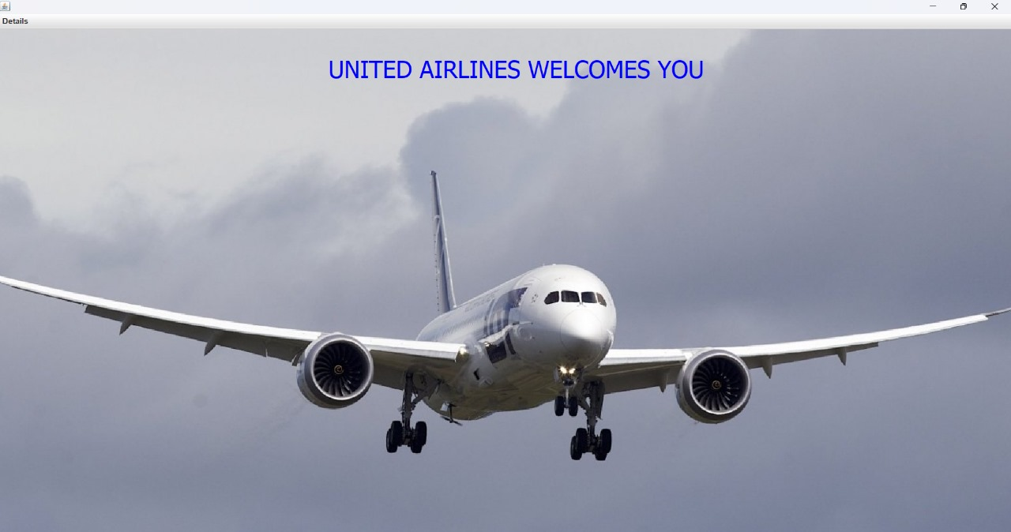

1. **Reserve or book a Flight by giving existing passport number, source, destination and date of travel:**

INSERT into reservation VALUES ('PNR-" + (100000 + random.nextInt(900000)) + "', 'TIC-" + (10000 + random.nextInt(90000)) + "', '" + passportno + "', '" + name + "', '" + nationality + "', '" + src + "', '" + dest + "', '" + flightcode + "', '" + ddate + "')"

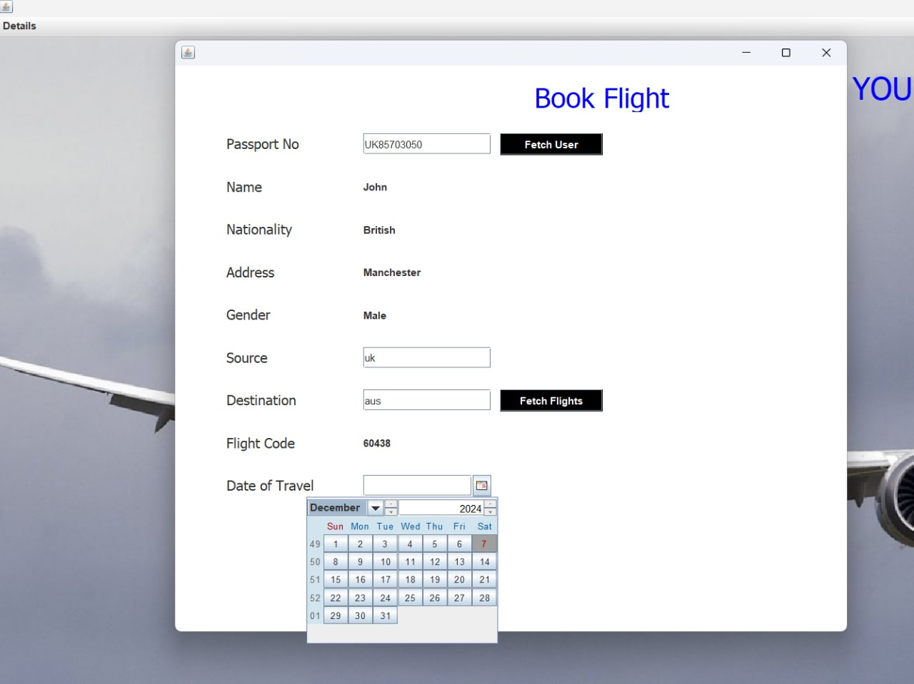

### Retrieve all the flight details:

SELECT * FROM airlinemanagementsystem.dbmsexl_csv

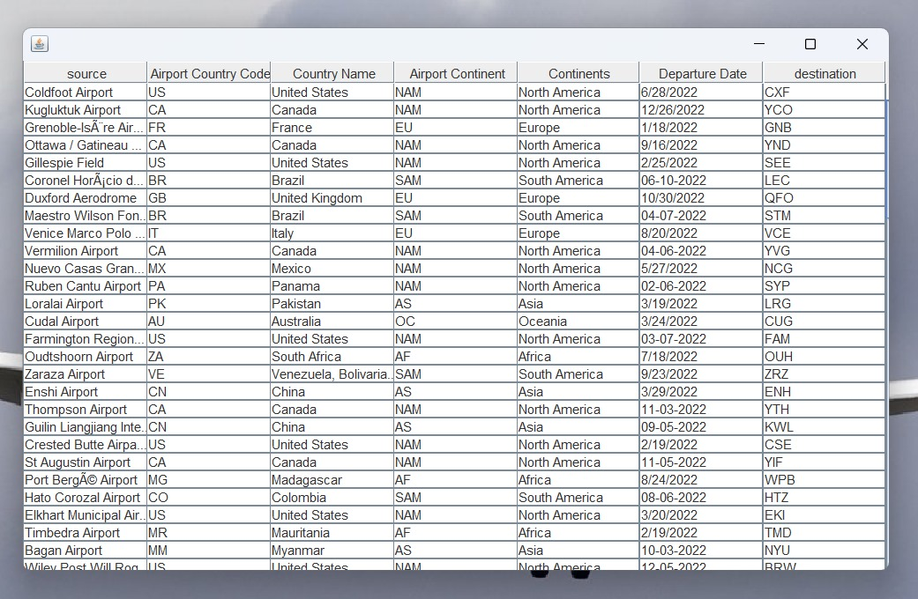

### Retrieve journey details based on pnr number:

SELECT * FROM reservation where PNR = '"+pnr.getText()

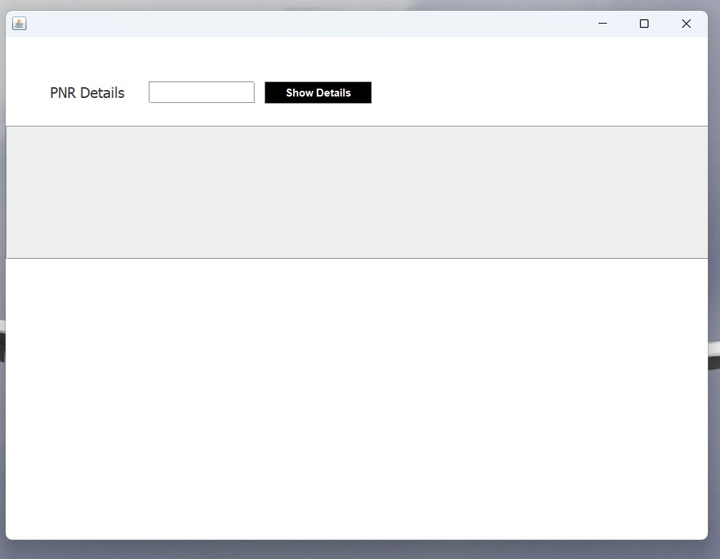

### Add customer details like name, nationality, passport number, address, gender and phone number :

INSERT into passenger VALUES ('" + name + "', '" + nationality + "', '" + phone + "',

'" + address + "', '" + passportno + "', '" + gender + "')";

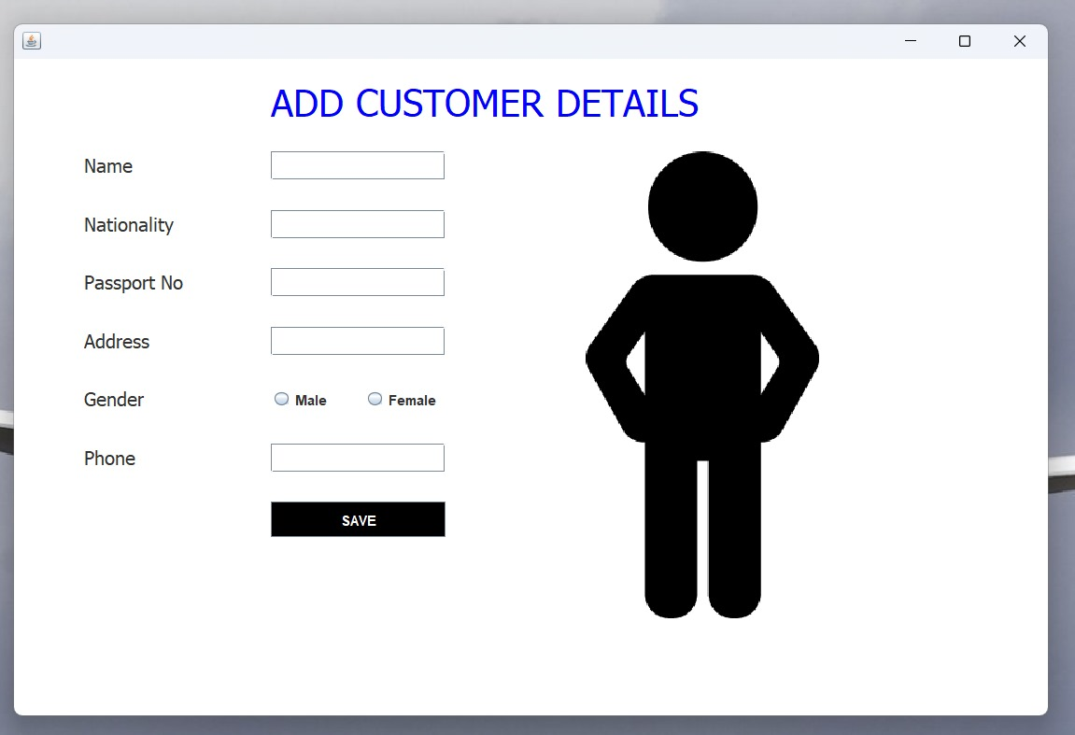

**CONCLUSION**

In the development of the ticket booking system for airways, we have crafted a sophisticated and efficient database schema, with meticulous attention to Primary and Foreign Keys. Our journey began with designing an ER diagram, which evolved into a well-defined schema capturing the essential aspects of the airways ticket booking domain.

In conclusion, our implemented model lays the groundwork for a robust and scalable ticket booking system, illustrating the practical application of database concepts alongside JDBC integration to create a user-friendly and functional environment. This schema is poised to contribute to the seamless operation and management of the ticket booking process, benefiting both airlines and passengers by enhancing efficiency and reliability.

**REFERENCES**

* GeeksforGeeks. (2024). Java and SQL Tutorials. Retrieved from https://www.geeksforgeeks.org/
* <https://www.javatpoint.com/java-awt>
* Github link: https://github.com/kunaltyagi9/AirlineManagementSystem